## Chemin d’Assise: Experience and reflection

**Who are we?**

Jayne and Michael, in our early 60s, are an Australian couple. In 2023, we walked along the Voie de Vezelay, the Camino route from Vezelay to St Jean Pied de Port, a beautiful introduction to the pilgrimage routes within western Europe. It was while in Vezelay that we became aware of Chemin d’Assise. Having been embedded in the spirituality of St Francis for many years, we committed to that journey for the following year, 2024.

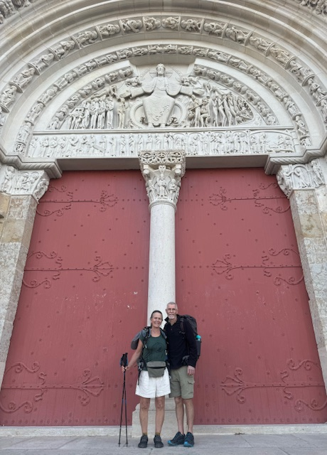

**What we did**

We commenced our pilgrimage from the humble chapel of La Cordelle in Vezelay in a prayerful mass celebrated with the local community, departing July 24. We arrived at the Basilica in Assisi on the morning of October 3, embraced by our emotion in the very different context of busy-ness, yet beautiful, with the pending celebrations of the feast day. We maintained our way along the marked route, coursing over La Chartreuse rather than the Chambery/Maurienne variant (a preference for mountains over flat country) and in the later stages, La Verna variant from San Miniato. The choice for the latter was on recommendation by previous pilgrims, and the enticement of entering into the many places that are part of the Francis story.

**How we did it**

We walked 1600 km over 67 days. That works out to be an average of 24 km each day. We had 4 – 5 rest days in that time. We had several long days in there – up to 40 km, balanced by shorter days. The length of the days was determined by potential accommodation, supply of food and water, remoteness and exposure, points of interest and A person standing in a river
at times, working around the weather. The route is mountainous and frequently very isolated. There were 40 days > 500 m vertical climb, including 16 days > 1000m vertical climb. This included one day of 2400 m vertical climb. While that might sound formidable, one just needs to be kind to oneself with less ambition in the first week or two by adopting shorter days. Fitness will develop quickly. The long days and substantial climbs certainly become achievable.

Walking from mid-summer into the autumn worked for us. There were hot days right through to September. Yet mornings are a very beautiful time to walk, leaving not too much distance to cover in the heat of the day. We experienced very little rain, and when we anticipated rain, adjusted our planning to work with that. The mountain passes were all very reasonable. We had heard that some passes were still covered in deep snow until mid/late June - which would have been very challenging for an April start. Each year will have its own story!

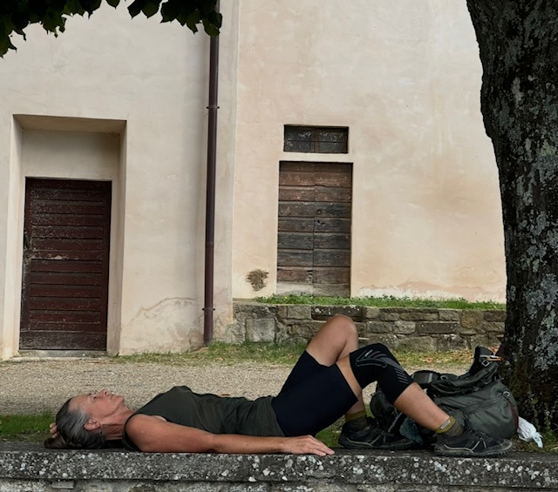Our packs served us well. Fully laden (with food, water, fuel etc), between the two of us, we carried about 18 – 20 kg. This felt quite reasonable. This included tent, sleeping bags/mats, stove, gas, eating gear and the like. We had a tablet (for journalling, back-up photos), and minimal clothing. We would carry enough food for 2 – 3 days, with emergency contingencies. There were times when we depleted these supplies. We were frequently grateful for the offerings of the blackberries to be found. Much of the route is quite remote. Villages and hamlets frequently quite small.

On the whole, the track is well marked, although it did take us a week or two to keen our eyes to the track markers. There was the occasional ambiguity, and we made the occasional error. That was part of the journey. We had translated the track notes into English. At times, the phrasing was a little challenging and even a little amusing. Yet they served us well. We printed notes and maps for about 10 days at a time to avoid anything too weighty. We did not use GPS. The map reading needs a little focus and basic map reading skill. How grateful we are to the many who mark the trails and document the detail to guide us along this beautiful way.

**Where did we stay?**

The accommodation guide is most helpful. We would usually look ahead 2 – 3 days, although still wishing to maintain flexibility in how far we would walk each day. When staying with families/homes, at least a day’s warning is appreciated by your host. We had a mix of places that we stayed in. We had a tent to give us some freedom to respond to our capabilities. We probably used the tent 10 – 15 nights. Sometimes campgrounds, sometimes in the forests of the mountains. It provided opportunity in some small villages where expected accommodation no longer exists. We would hence stay in church yards, or municipal facilities. We had a kind farmer offer her pear orchard one evening. The most memorable of our stays are with families. The warmth and joy and beauty of these hosts and homes is indescribable. How deep our relationships developed in the course of a few hours. These nights were particularly special. We stayed in small hostels, in convents, presbyteries, church dormitories and the occasional hotel. And for the most part, we were alone. It was not until our last days, as we neared Assisi, did we share dormitories.

**The journey**

We created time in our lives to walk the complete journey in one effort. We are pleased that we did and would recommend others to do so if feasible. We met just two other pilgrims in our time (until the last week), who were each walking from near the French/Italian border. We heard of others who walk a week or two over a number of years. Constraints of time may necessitate this. However, it is our experience, the longer the journey, the deeper the experience. It takes time to let go of the clutter of the mind. The repetition of walking more and more allowed us to empty and sit comfortably in that space.

This journey is one of profound beauty. It is not that every place is picturesque, or every village is welcoming. It is not that days with uncertainty of supply, or niggles in the knee or foot do not raise the occasional doubt. It is the accumulation of the challenging days, the accumulation of the beautiful moments; the ordinary accommodation and the joyful and loving stays with families; the quiet moments of mountain nights; the sacred spaces in a crypt or forest, the grandeur of alpine passes and the beauty of the frescoes; the glass of water offered by the villager. It is this accumulated experience that is internalised, contextualised by the complete emptying of the mind. It is the journey into one’s soul. The opening of our hearts and minds to witness the kindness and see the beauty of all that is around us. Unexpected moments of deep joy. When we arrived in Assisi, seated in the Basilica, we cried. It was not that we were elated that we had reached our destination. Moreover, we nursed an acute awareness that the journey had worked its way into the deepest recesses of our hearts. Our journey does not end but rather yearns for new horizons; the unexpected explorations of the love that had A person standing in a grassy field with mountains in the background
been revealed to us in so many forms. Our early days in the beautiful fields of Burgundy gave reason to ponder on the landscapes. Then through the mountains and ranges – Chartreuse, the Alps, Monti Liguori, Tuscan Apennines - a statement of grandeur, humbling our form to be amongst them. The last days of our walk brought us into the land steeped in the stories of St Francis. From the mystique of La Verna to the solitude of Sasso Spicco, we had cause to reflect on the spirit of this simple and remarkable man: that we value nature in all its forms; that we celebrate the human spirit that flourishes in solitude and delights in companionship.

This is no ordinary journey. It is transformative. We are no longer the same.

**Happy to help others…**

For those who may need tips or have questions, we are happy to share our thoughts. We can be reached…